24.22: a) 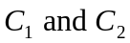 are in parallel and so have the same potential across them:
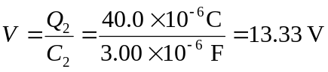
Thus Since 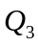 is in series with the parallel combination of 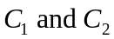, its charge must be equal to their combined charge: b) The total capacitance is found from:
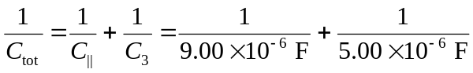
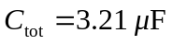
and
